Exploring a New Land

In the late 1400s no one had charted the Atlantic Ocean. Europeans thought that they could reach China by sailing west. They did not realize that North and South America were in the way.

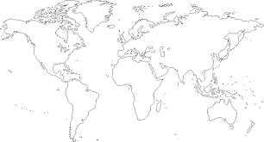

The star notes Europe’s location and the square shows where China is located.
Can you identify North and South America?

Christopher Columbus tried to voyage to Asia in 1492, but he reached Cuba instead. He did not realize that he was in an unknown land. The Spanish, who arrived after Columbus, searched for cities of gold, but they did not find them. They did, however, take over many Native American lands.

French and English explorers came to the Americas, as well. They came to trade with the Native Americans, and to claim land for homes, farms, and cities. The English colonies later became the United States of America.

1. What does the map help you to understand? _____________________________

___________________________________________________________________________

2. Where were the Europeans trying to go by sailing west? ___________________

___________________________________________________________________________

3. Why couldn’t the Europeans sail west to get to China? _____________________

___________________________________________________________________________

4. What is one reason that the French and English came to the Americas?

___________________________________________________________________________

___________________________________________________________________________

