How Earthquakes Happen

Earth’s top layer (the crust) is made of plates. When two plates slide past each other, pressure builds along their sides. When the pressure becomes too much, it is released. That is when an earthquake happens.

Think of it like a rubber band. Imagine that you stretch the band more and more until, finally, it breaks. Snap! That is how an earthquake happens. The pressure builds, and then—snap!

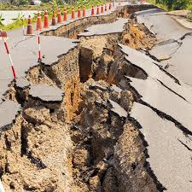A crack in a road after an earthquake in California.

Once the pressure snaps, things start to shake. The shaking moves away from the focus across the land. On land, you can see the ground move. Build-ings move and shake, too. If the earthquake is strong enough, buildings can fall down.

Most earthquakes are mild with little shaking. Most of the time everybody is all right and things are fine. Earthquakes are normal events on Earth.

1. How are earthquakes like a rubber band? _________________________________

____________________________________________________________________________

2. What is the top layer of the Earth called? __________________________________

___________________________________________________________________________

3. What are two things that can happen when pressure builds on the Earth’s crust?

___________________________________________________________________________

___________________________________________________________________________

